For paralell execution you need to have maven-surefire-plugin installed in POM.xml in IDE, it looks like this:

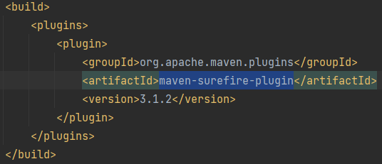

The runner class should have the override method

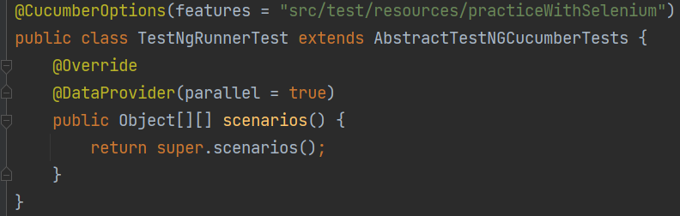

The class responsible for initialization of WebDriver should use ThreadLocal class. It creates copy of variable (driver) for every thread. For example:

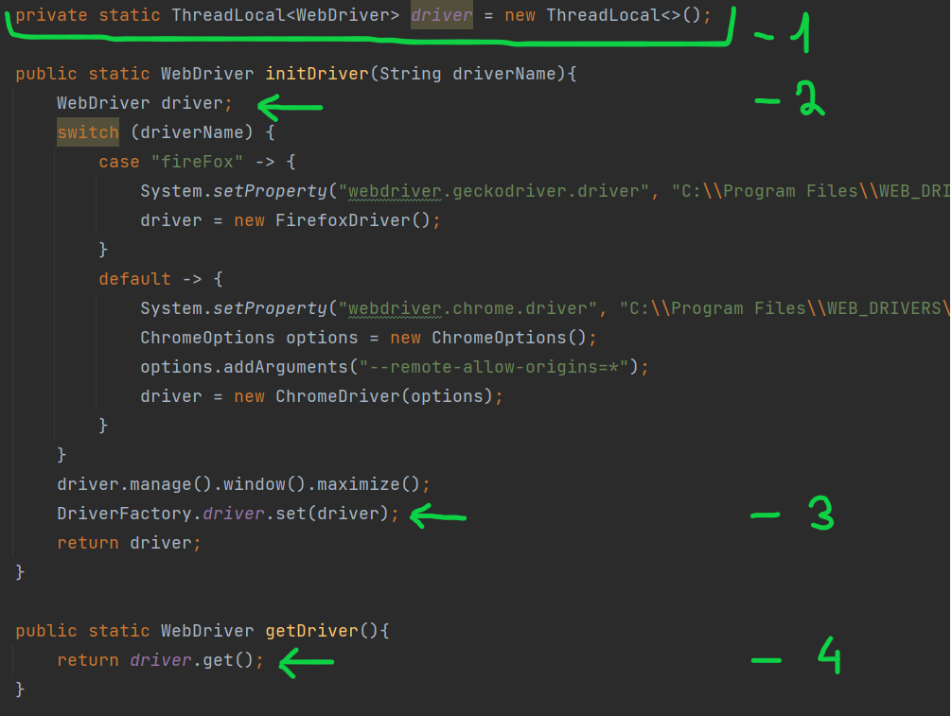

Where:

1 - class variable

2 - local variable

3 - Important step that sets the local instance of variable

4 - returns the thread specified version of driver